The politics of art in a glocalized world

For some years now I have been interested in the relationship between art and social research and the transformative role of art and creativity. I am personally and politically committed to working with artists, individuals, groups and communities at the intersections of social research and community and participatory arts using methodologies that are creative, visual, sensory, participatory, that raise awareness of what Hamish Fyfe calls “the Quotidian experience of people’s everyday lives.”

I am not suggesting that participatory approaches are the only way to do research that seeks to develop social justice, create space for dialogue and help us to think differently, for the critiques are many: such as using definitions of ‘community’ that are simplistic- homogenising that erase differences and power relations; the incorporation of participatory methods or models into what are effectively top down approaches to community consultation –i.e., the rhetoric of participation; funding can be short term and so work against the ethos of sustained participation; the use of participation in a responsibilising way which serves to makes people feel responsible for their own fate.

I do agree with Francois Matarasso who said “Democracy should not be mistaken for a natural outcome of development. It needs to be supported and protected and given it’s function as a creator of meanings and a carrier of values, culture is a powerful force within any strong democracy” Matarasso, Francois. (2006). ‘Many Voices: The importance of cultural diversity in democratic society’, Unpublished lecture given at Vara Konserthus,
Sweden, 25th September:
http://homepage.mac.com/matarasso/FileSharing20.html. [Date of access:
30th November 2008

Examples of cultural democracy involving participatory and community arts include:
The Capture Wales digital storytelling project http://www.bbc.co.uk/wales/audiovideo/sites/galleries/pages/capturewales.shtml , and
Working together to Create Change (www.safetysoapbox.co.uk) .

The Sense of Belonging exhibition (see http://www.guardian.co.uk/society/gallery/2009/jan/13/sense-of-belonging-exhibition?picture=341562662 ) is the latest project in a trajectory of participatory work that began in 1999 using arts based research conducted in collaboration with ‘exiled writer’s ink!’ London and City Arts, Nottingham , Afghan community organisations in London and Bosnian communities in Derby and Nottingham. This was followed by participatory action research with City Arts and Refugee Action that led to a cultural strategy for including refugees and asylum seekers in the arts and cultural infrastructures in the East Midlands. Out of this work emerged a regional network called Making the connections: arts, migration and Diaspora (www.makingtheconnections.info and www.beyondbordersuk.org ) a network of new arrivals and emerging communities, statutory and voluntary sector agencies, community arts organisations and regional Universities who led ten workshops and seminars on subjects decided at the launch event. The Sense of Belonging knowledge transfer project (also funded by the AHRC) emerged from this network – and is collaboration between four community arts organisations and Loughborough University. One outcome of our collaboration is the sense of belonging exhibition.

A key question we might ask in relation to the politics of art in a glocalised work is

how might artists and researchers (artists/researchers) work together to support cultural democracy in the current political climate – where impact is a current focus and the arts and participation are used to reinforce government agendas and targets relating to ‘participation’ and ‘active citizenship’ ?

And a related question - what is the importance of community and participatory arts in a glocalised world?

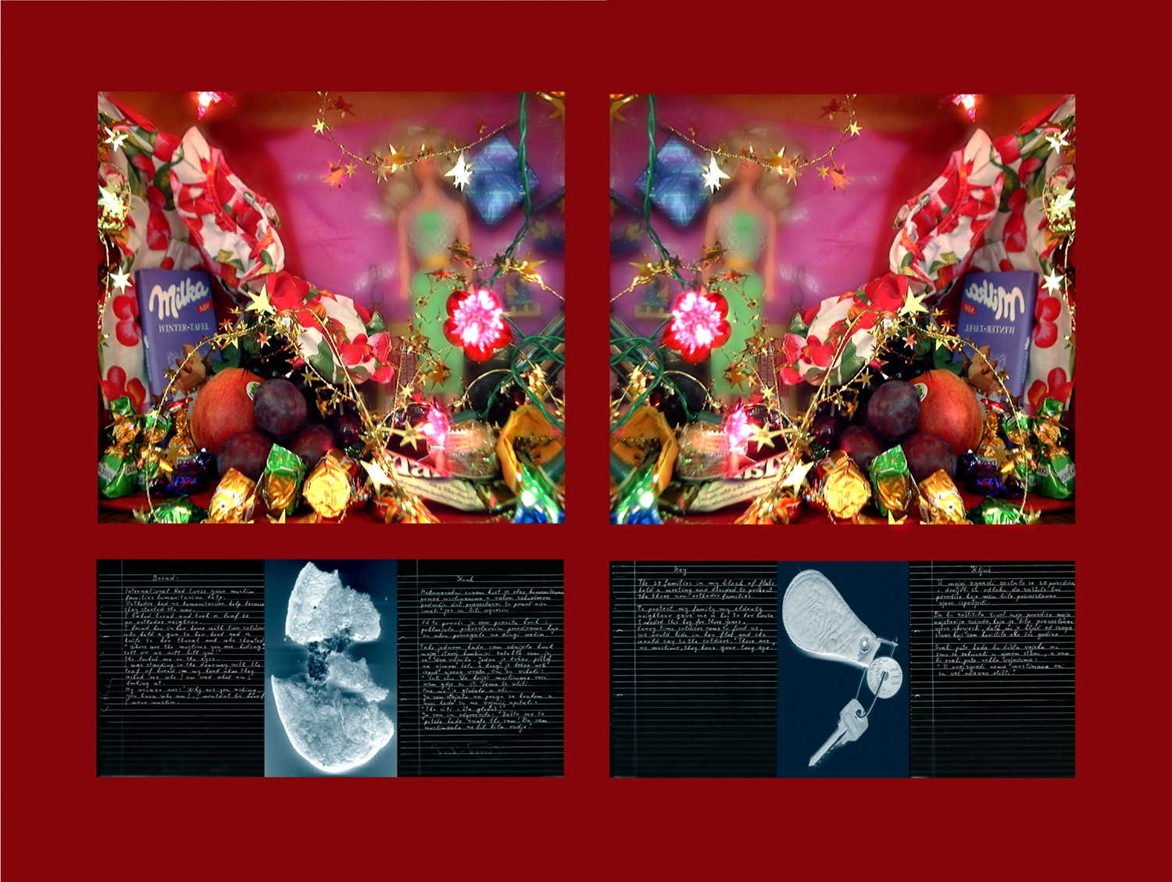
Fahira Hazedic Good neighbour

